Know why a credit rating check is important for your company

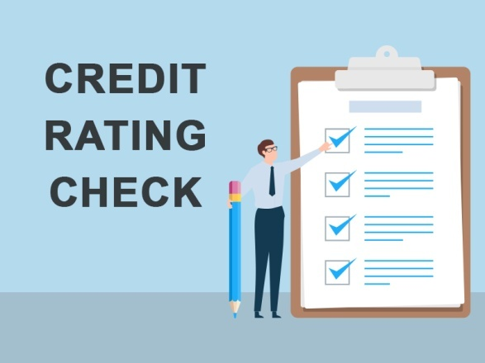

Running a business is no joke. It requires a lot of insight and financial back up for sustenance in the long run. Not only is the business your source of income, but it is helping several others earn their means of livelihood. Hence, it is important to keep an account of how well your business is established and the only way to check it is to perform a [credit rating check](https://scocre.com/).

If you are wondering why it is important to run a credit check then we tell you that it is the key to your company’s financial standing. It is an analysis of the credit risks that is linked with a financial instrument or a financial entity. Simply put, credit ratings are grades that are awarded on the basis of a company’s financial history of borrowing and help the lenders determine its repaying capacity.These grades are awarded or designated by certified and reputed credit rating agencies.

Now that we know the importance of credit ratings, let us take a detailed look on the various factors revolving around it, including the advantages of performing a credit rating checkfrom the borrower’s point of view.

**What is credit rating scale?**

The credit rating scale is a combination of alphabets and symbols such as BBB, + and ranges from A++ to D. If the grades are higher (A++) then the chances of sanctioning the loan amount is higher and the amount gets disbursed easily into your account, and if the company fairs poorly on the credit rating scale (C or D), then the lenders may reject the proposal or charge a higher rate of interest and have an upper hand in determining the other terms and conditions of the loan.

Advantages of performing a credit rating check

**Betters company’s image:** Running a check regularly, improves the image of the company in the market as the owner makes it a point to work on factors that are pulling down the grades. So, such companies have a strong financial reputation and lenders are always ready to help or even come up with loan offers.

**Excellent marketing tool:** The customers, dealers, suppliers, investors and others feel confident with companies that have high credit ratings. On the contrary, if the companies are not popular or rank low, then the investors are apprehensive about getting their returns.

**Finds you a place among famous companies:**  [A regular credit rating check](https://scocre.com/blogs/types-of-credit-rating.php)can get you on the list of big companies. This is because good ratings help you grow and expand the company’s wings by getting the loans sanctioned easily.

**Conclusion**

So, you see, it is important to realise that you cannot ignore performing a credit rating checkas it is the key to your businesses’ success.